High-level Programming Languages
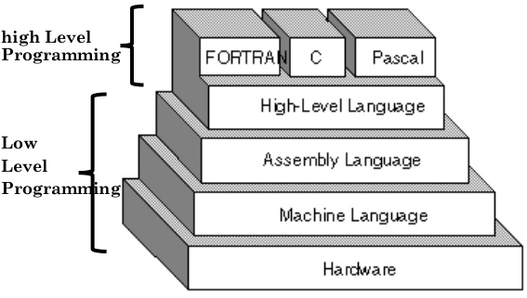
A low-level programming language is closer to machine languages and less human-readable.
A high-level programming language is closer to human languages and easier to read, write, and maintain.
C, Pascal, and FORTRAN are considered high-level programming languages, but as newer and easier languages, such as Java, Python, and Processing, become much more maintainable there has been a slow movement of mid-level programming languages [C, Pascal, FORTRAN].
Here is a list of programming languages ranging from very low to very high level:
- Machine code could be considered the lowest level programming language. This is probably the most difficult with human-interaction. Example:

ba 0c 01
b4 09
cd 21
b8 00 4c
cd 21
48 65 6c 6c 6f 2c
20 57 6f 72 6c 64
21 0d 0a 24

- Assembly language is at the level of telling the processor what to do. As you can see, it is much more readable than machine code but still rather difficult. Example:

mov dx, 010ch
mov ah, 09
int 21h
mov ax, 4c00h
int 21h
db 'Hello, World!', '$'

- C is a step up from assembler. You have to be more specific with abstract terms, but nowadays, this would probably be considered a low-level language. // C hello world example:

#include <stdio.h>
int main() {
printf("Hello world\n");
return 0;
}

- C++ can do everything C can do, and adds the capability to abstract things into classes. C++ would probably be considered a mid-level language nowadays. // C++ hello world example:
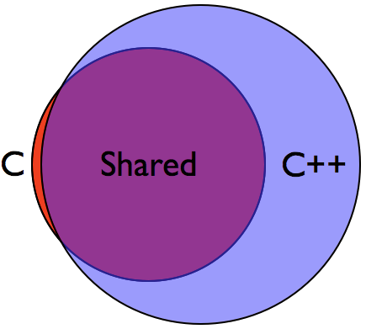
#include <iostream>
int main() {
std::cout << "hello world!\n";
return 0;
}

- Java/C# do many similar things as C++, but also including some features from C that C++ could not do, such as pointer manipulation. These languages also have a garbage collection, while this feature had to be done manually in C++.

// Java hello world example:
public class HelloWorld {

public static void main(String[] args) {
// Prints "Hello, World" to the terminal window.
System.out.println("Hello, World");
}
}

- Python/Ruby are high-level languages, and allow you to forget about a lot of the details you would need to specify in other languages like Java and C++.

// Python hello world example:
print("Hello, World!")

As you notice, all these examples are a simple program to print “Hello, World” to the screen. In machine code, this was essentially impossible for a human to read, but as we move into higher languages, the code became shorter, cleaner, and easier to read, write, and maintain.

Compiler
A compiler is a program that translates from a particular programming language into machine code that a computer’s processor uses. This is necessary for the hardware to process the user program. So the higher the programming language, the more abstractions for the programmer/program.

