Fixed Point (Integers)
A fixed point representation is used to store integers. So we are interpreting a fixed number of bits to a number that we can understand. There are 4 ways for integer representation:
- Unsigned Integer
- Offset Binary
- Sign and Magnitude
- Two’s Complement
Refer to the charts below as we explain the differences between these 4 representations.
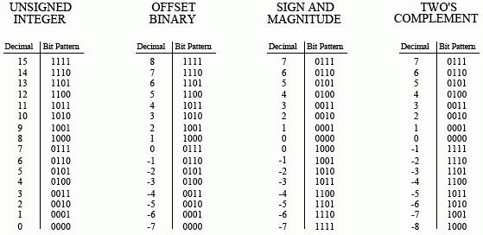

Unsigned Integer
The unsigned integer is a simple binary format. Negative numbers cannot be represented in this format.

Adding and Subtracting
Binary math on paper can be accomplished in multiple ways. One way is to convert the binary numbers to decimal, complete the computation, and return the result back to binary. Below are examples of how to perform these computations staying only in binary.
Adding
Just like decimal numbers, when adding binary numbers, add the numbers straight down, carrying over a 1 when necessary, very similar to carrying the 1 in decimal addition.
₁ ₁ ₁
000 010 001 011
+101 +101 +001 +011
101 111 010 110

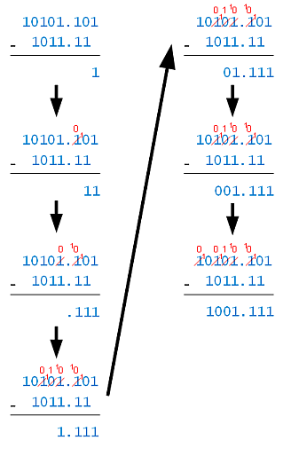
Subtracting
For subtracting, sometimes lesser values need to borrow from greater values, similar to subtraction in decimal. To the right is an example and included steps for binary subtraction.
- 1 – 0 = 0
- Borrow to make 10 – 1 = 1
- Borrow to make 10 – 1 = 1
- Cascaded borrow to make 10 – 1 = 1
- 1 – 1 = 0
- 0 – 0 = 0
- Borrow to make 10 – 1 = 1

Sign and Magnitude
The sign and magnitude allows for negative numbers. The first bit on the left side signifies whether the representation is negative or positive. A 0 will represent a positive number or 0 and a 1 will represent a negative number or 0. The range of numbers that can be achieved would be half of the largest number (e.g. 4-bit largest number is 15, so the range will be from -7 to +7). This is the only number system with two zeros as well (+0 and -0 are just 0).
The most significant bit (left-most bit) of a binary number can be used to represent the sign of the number. The other bits are used to represent the magnitude. Below is an example of showing the values “3” and “-3”. Notice that the magnitude is the same for both binary numbers, but the sign reflects whether it is negative or positive.
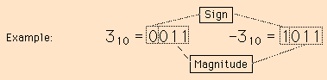

Offset Binary
Offset binary is commonly used in image processing to display negative pixels’ values. The offset binary allows for negative numbers. The first bit on the left side signifies whether the representation is negative or positive. A 1 will represent a positive number and a 0 will represent a negative number or 0.
This is useful for binary counters. The magnitude revolves around a “Working zero”. For example:
- Start with 4 bits, and the highest you can go with four bits is 15 (1111).
- Take half of your highest number, in this case it will be 7. (round down)
- Now to find out the Working zero for 4 bits, we must subtract half from the largest number.
Largest number (15) 1111
Subtract half (7) -0111
Working zero 1000
So we know that 0 for a 4-bit offset binary will be “1000”
- Now if we want “+4” or “-4”, we just have to add or subtract from our working 0.
To get +4 1000 To get -4 1000
+0100 -0100
1100 0011

Here is another example, but I changed it to 8 bits.
- Maximum number is 11111111 which is 255 (decimal).
- Half of that is 127 (round down).
- Working zero:
Largest number (255) 1111 1111
Subtract half (127) -0111 1111
Working zero 1000 0000
- Now, if I want “+101” and “-23”
To get +101 1000 0000 [working zero] To get -23 1000 0000
+0110 0101 [101 in binary] -0001 1001
1110 0101 [101 in offset binary] 0111 1000

Two’s Complement
Two’s complement is the easiest for hardware design and the most common format for general purpose computing. Two’s complement allows for negative numbers. The first bit on the left side signifies whether the representation is negative or positive. A 0 will represent a positive number or 0 and a 1 will represent a negative number. This format has the same range as offset binary and sign and magnitude but it is more common to see this format in a question or lesson plan than the other two formats.
To produce Two’s complement numbers are in two parts, positive and negative.
Positive numbers (including 0) are similar to unsigned integer (binary), they are written the same way.
Negative numbers have a few extra steps. For example, to produce the number -4:
- Write the binary number for 4 0100
- Take the complement of it 1011
- Add 1 1100
Another example for -7:
- Write the binary number for 7 0111
- Take the complement of it 1000
- Add 1 1001

Overflow
Overflow is an error that occurs when the resulting value of an operation performed on valid representations of numbers is out of the range of valid values. That is, the resulting value is greater than max or less than min. So you may have heard of a 32-bit system or a 64-bit system, this is the number of bits used in computation and when a computation goes above the fixed bits, an error will occur. Let’s do an example but with an 8-bit system.
So let’s add 150 and 249: 150
+249
399
The answer is 399, but we need to do this in binary.
₁ ₁ ₁ ₁
[150] 1001 0110
[249] +1111 1001
11000 1111
Since this is an 8-bit system, an error is thrown due to the answer being 9-bits. In some systems, the extra bit (highlighted in green) is simply ignored and returns the rest. In this case, 1000 1111 is 143.
As we already know, 150 + 249 = 399, not 143. This result is an overflow error.

