Bits and Bytes
Prerequisite: Know Binary and Hex. View previous document, “Binary, Decimal, and Hex” for help.

Bits
A bit (short for “BInary digiT”) is the smallest unit of data in a computer. The bit can be represented by a 1 or 0. A single bit can be used to represent on/off or yes/no but a string of bits can represent complex data.
For example, computers run on electricity, so when a computer wants to send information from one place to another it sends these "pulses" of electricity over a wire. A higher voltage pulse will mean a 1, and a lower voltage pulse will mean a 0. But there are other parts of a computer that still use 0s and 1s that aren't electric, like the hard drive. The hard drive stores 1s and 0s by changing the magnetic poles of small parts of a metal disk. Positive and negative charges would be 1s or 0s.
Binary | Hexadecimal
0000 | 0
0001 | 1
0010 | 2
0011 | 3
0100 | 4
0101 | 5
0110 | 6
0111 | 7
1000 | 8
1001 | 9
1010 | A
1011 | B
1100 | C
1101 | D
1110 | E
1111 | F
A nibble (sometimes spelled nybble or nyble) is a string of four bits. Nibbles can be used to represent a single hexadecimal digit as there are exactly 16 combinations between those four bits.

Bytes
A byte consists of 8 bits, sometimes also referred to as an octet. A byte generally comprises 8 bits that represent a letter in the alphabet, a single digit number, a punctuation mark, or other character.
So how exactly does a byte hold information? For example, ASCII tables are used to translate a byte to a letter in the alphabet. Below is a small portion of the table. On the left hand side is the value and on the right side is the letter it represents.
Fox example: This word is four bytes long.
Binary: 01000010 01001001 01010100 01010011
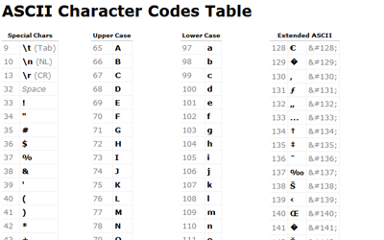Decimal: 66 105 116 115
ASCII: B i t s
So the binary stream is the word “Bits”.

This is only one example. Bits and bytes can hold all digital data at its lowest level.

